ACTIVITY 9.1
PositiveCheck
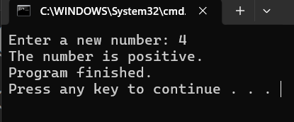

ACTIVITY 9.2
VotingCheck
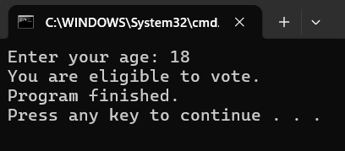
ACTIVITY 9.3
GradeEvaluator
